CS561 -ARTIFICIALINTELLIGENCELAB

**ASSIGNMENT-4 : HILL CLIMBING**

**Intaj Choudhury – 2211MC09**

**Ankit Anand – 2311MC04**

**Khushbu Bharti – 2311MC21**

**QUESTION :**

A local search algorithm tries to find the optimal solution by exploring the states in the local region. Hill climbing is a local search technique that always looks for a better solution in its neighbourhood.

**a**. Implement the Hill Climbing Search Algorithm for solving the 8-puzzle problem.

**b**. Check the algorithm for the following heuristics:

i. h1(n) = number of tiles displaced from their destined position.

ii. h2(n) = sum of the Manhattan distance of each tile from the goal position

**Algorithm:**

**STEP1 :** Take the initial state of the puzzle from user. Target state is fixed.

**STEP2 :** Check whether the puzzle is solvable or not by counting number of inversion.

**STEP 3 :** If puzzle is Solvable. We initialize the constructer of class “state” with parameters value and hx , creating object for initial state.

**STEP 4 :** Taking input from user for the hx function. According to the input we are calculating the hx value.

**STEP 5 :** Calculate the hx value for all the children of the of the current node .

Putting the heuristic value of all children in open list and then sorting the list.

**STEP 6 :** Check the minimum hx from the open list (open[0])

If h value = 0 :

Then target state is reached.

Exit.

If this h value is greater than the hx of parent state,

then local maxima is reached and searching will end.

Exit.

If this h is less than hx of parent

Then we will put current state = open[0]

Repeat step 5 and step 6.

If the h value is equal to hx of parent

We will check for flat. if it’s a flat then exit, otherwise repeat step 5 and 6.

Case 1: Target reached

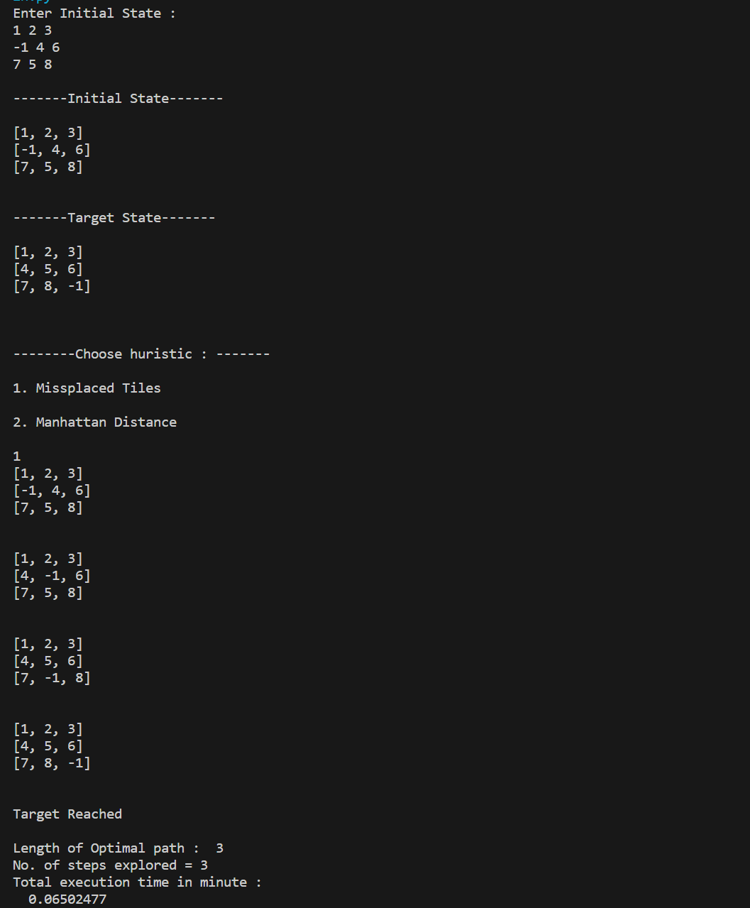

Case 2 : Local Maxima

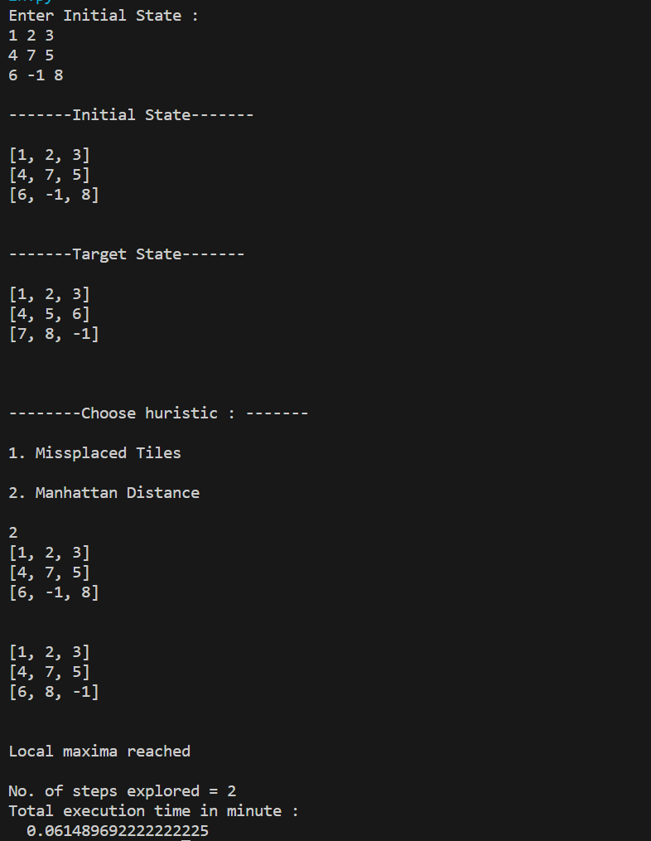

Case 3 : Stuck in Flat or Shoulder

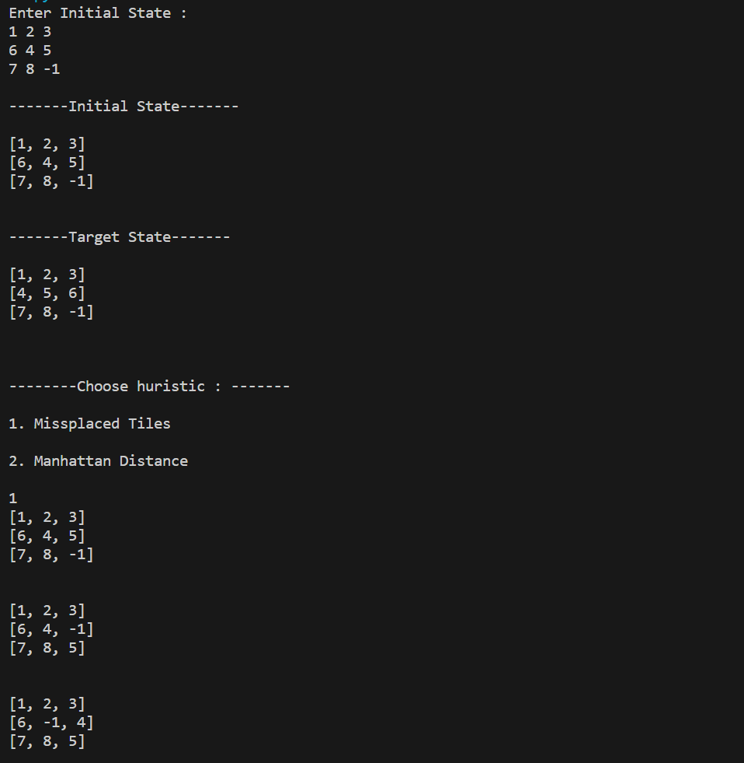

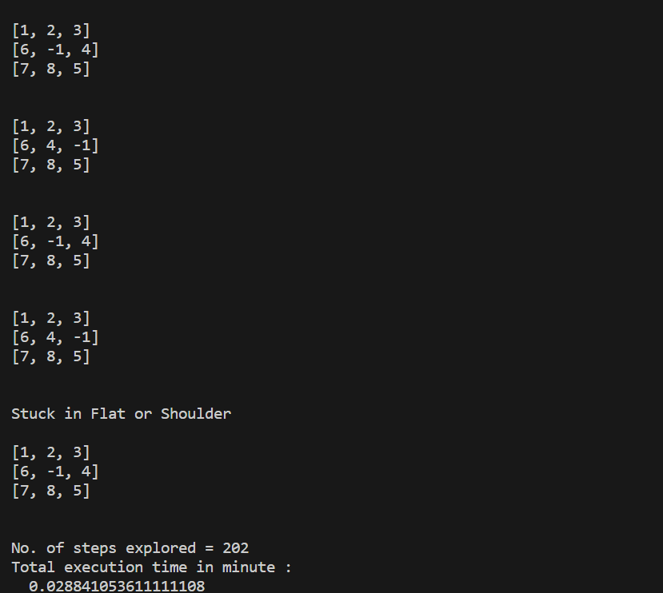

Demonstration for a sample input-

